**PROJECT –2 Stanford Library**

**By – Jenifer Pushparaj**

**Note:** Library Management System is hereby referred in the case study as LMS

**STAKEHOLDERS**

|  |  |
| --- | --- |
| **ACTOR** | **What he can do on the Software Created** |
| Student | * Student can “Check out and Return” materials available for issue. * Student can identify materials currently issued to their unique identifier. * Student can know about the due date of material to be returned. |
| Library Staff | * Library Staff can “Check Out” and “Return” materials available for issue. * Library Staff can calculate materials due dates. * Library Staff can generate materials reporting, both Standardized Reporting and Ad Hoc Reporting. * Library Staff can determine accurate penalty calculations for clients. |
| Management | * Database able to manage millions of records. * Database will be secured and will grant access via multiple entry points, for both Student and Staff users. * User Interface will allow users to manage materials access, regarding:   + search/location of materials,   + issue and return materials,   + penalties calculations,   + locate/map return stations,   + determine scheduled return date |

**PROBLEM DEFINITION AND SOLUTION**

Here you can mention why we need this library system for both: the library and the student. Can write more than 1 point.

**Problems with the manual library:**

• A lot of time is wasted managing the manual library. • The number of employees needed to manage the library is high. • Fine calculation is a tedious and time-consuming affair. • No reports could be generated on books issued due to the manual system. • It is difficult to manage 4 million books present in the library.

**Solution:**

This LMS system is needed for Library management because to reduce maintenance, costs associated with staffing, materials tracking, allow for materials metadata reporting, Enhanced reputational benefits for both management and staff.

**Problems with the library system for students:**

Students could deposit the books only in the library timings.

**Solution:**

This LMS system is needed for Students for the cases to get improved in learning experience, and educational benefits associated with ease of use, time reduction for accessing, using, managing and returning materials, avoid penalties expenditures, allowed preferred access point.

**Advantages of LMS**

* Reduce overheads and increase the productivity of library staff.
* Cost reduction.
* Up-to-date records of all books, research papers, magazines, and other materials available in the library.
* Improve student engagement in the library.
* It will generate dynamic reports for better decision-making.

**EXISTING SYSTEM**

* It is the manual library where the paper-based maintaining, organizing, and handling of countless books became a nightmare.
* Currently none of the features is mentioned.

**PROPOSED SYSTEM**

New software is developed to sort this problem with existing system. In this we can store the meta data of the users.

* User friendly interface through mobile, desktop and kiosk.
* Improved learning experience.
* Improved educational opportunities associated with ease of use.
* penalties expenditures are avoided.

**Flowchart for LMS**

Create and provide a flow chart for the system.

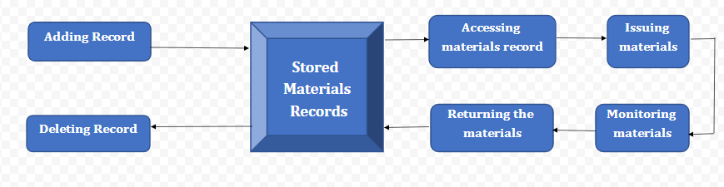

**SCOPE using Use Case Diagram (UML)**

Create a use case diagram including all the actors and processes for an end to end process of the system.

**SCOPE using Context Diagram**

Depict the scope using Context diagram.

**DATA FLOW DIAGRAM**

Create a data flow diagram.

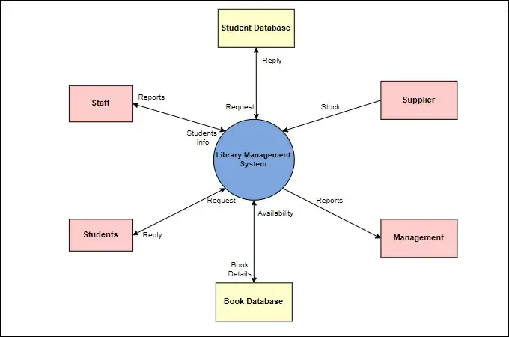

**IN SCOPE**

* LMS System will track materials metadata.
* LMS System will track materials location.
* LMS System will track materials status.
* LMS System will track materials overdue penalties debits and credits.
* LMS database will conform to Stanford information systems non-functional requirements standards regarding accessibility.
* Autogenerated notifications for due-date, availability and penalties payments.
* “Kiosk” access points on location will be used by students and staff to locate and manage materials.
* Browser application will be used to allow web access by students, staff, and management actors, for materials activities.
* Mobile application will be used to allow web access by students and staff, for materials activities.

**OUT OF SCOPE**

* LMS will not manage materials which is not owned by the library.
* LMS will not manage fees unrelated to the library.
* LMS will not manage systems security unrelated to the library.
* Browser access will be limited to Stanford-approved and supported browsers.
* Mobile application will be limited to Android OS devices.
* Materials access will be limited to items allowed by governing copywrite laws.

**Wireframes:**

Create sample wireframes for the system. Capture what screen will be show to the library employees to create records for each book and at what stage in the system.

**ER DIAGRAM FOR THE SOFTWARE**

Create an ER Diagram for the system you have designed.

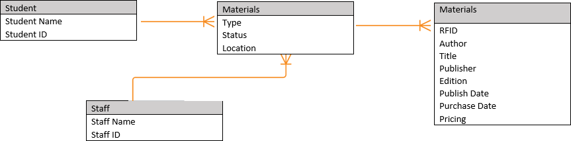

**FUNCTIONAL REQUIREMENTS**

* The LMS should keep records of different categories of material available in the library like books, magazines, research papers, journals, and newspapers.
* The books should be classified subject wise in the software.
* Each category like books, magazines, research papers, journals, and newspapers will have different issuing periods. For example, a book can be issued for 3 weeks but a magazine only for 1 week. Newspapers cannot be issued for use outside the library and so on.
* Every reading material available shall have a RFID tag on it. The record of the same will be stored in the database. For each reading material record information like author, book name, publisher name, book edition, date and year of publication, cost of the book, and date of purchase of the book.
* When a student wants a reading material from the library, they will select the material and go to the checkout counter. The library staff will use a RFID reader to capture the details of the book. The student's name is tagged along with the book they borrowed.
* System will record the issue date and return date of the book.
* System shall do an automatic calculation of fines in case of delayed return of books.
* Library staff should be able to search for books on the LMS by search criteria like name of the book or author.
* Students should be able to access the library system online to know the return date. They should be able to access it via the web or mobile interface.
* System shall send automated emails to the students 3 days before the return date to avoid late return of books.
* Access to free e-journals and e-books through the software.
* Anti-theft detection: RFID readers are placed at the exit gate of the library and the RFID reader tracks books to a range of 2 meters and would trigger the alarm with a loud sound in case anyone tried to pass through the gate with an unissued book.
* Book drop box stations to be installed outside the library: Students can return books at any time in the RFID enabled book drop box station. Student’s loan is immediately cancelled once the student deposits the book in the drop box.
* Management would like the following reports:
  1. Which books are most rented?
  2. Records of issued and unissued materials in the library (management will decide whether to stock them or not)
  3. Amount of fine collected in a day, week, and month.
  4. Number of lost books
  5. Report on total number of books, journals, etc.
  6. Age of books, that is, which books are more than 20 years old.

**NON-FUNCTIONAL REQUIREMENTS**

### **System Requirement:**

* Data should be stored in cloud.
* Highly secure, scalable, and reliable.

**Usability:**

* KIOSK,
* Mobile Access,
* Desktop Access

**Environments**

* Browser support limited to latest 3 versions of Safari, Chrome, Edge, Explorer.
* LMS can be used on any Windows run and MAC run computers.
* Mobile application will be limited to Android OS devices.